Project report

# introduction

In today’s digital age, social media has become an integral part of our personal

And professional lives. Whether you’re a business, influencer, or simply an individual looking to express yourself online, the impact of visually appealing and engaging social media content

Be overstated. This project report deles into the use of canva, a popular and user-friendly

Graphic design tool. As a versatile solution and shareable content for social media platforms.

## 1.2 purpose

To crate visually appealing and engaging social media posts. To streamline the post design process. To improve the overall on our social media platforms

2.problem definition &design thinking

## 2.1 Empathy map

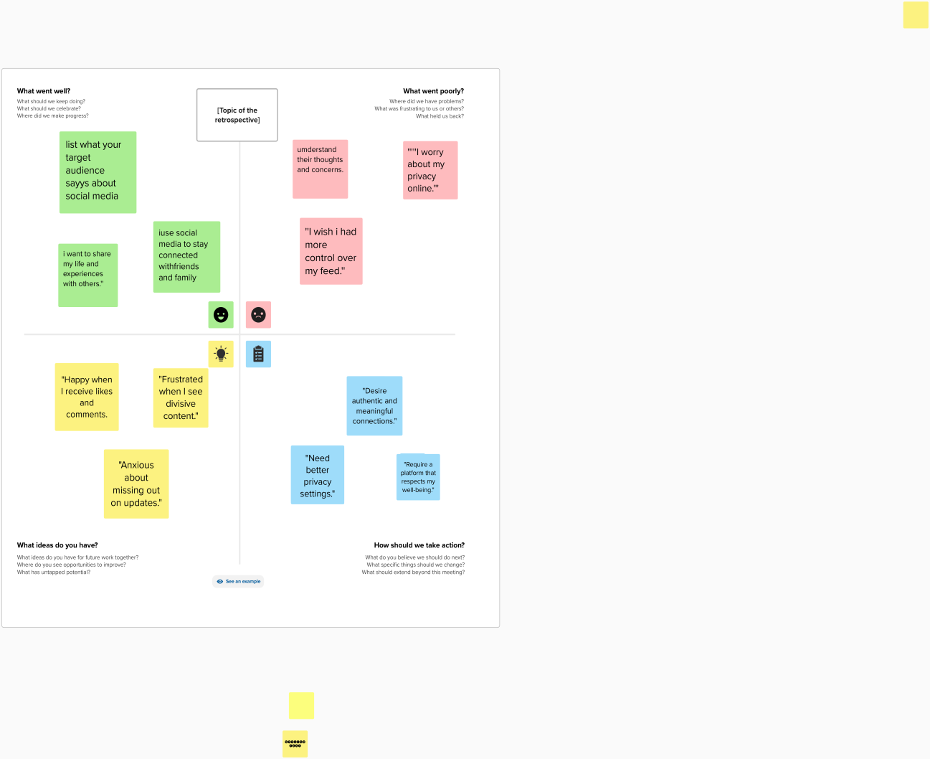

## 2.2 ideation &brainstorming map

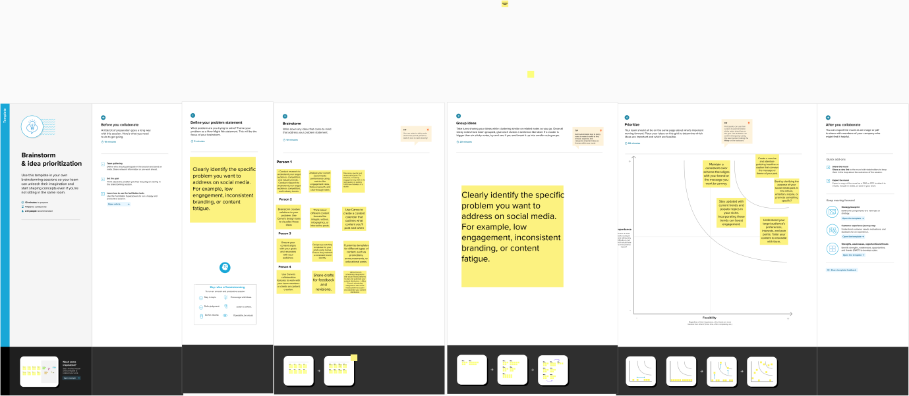

## result

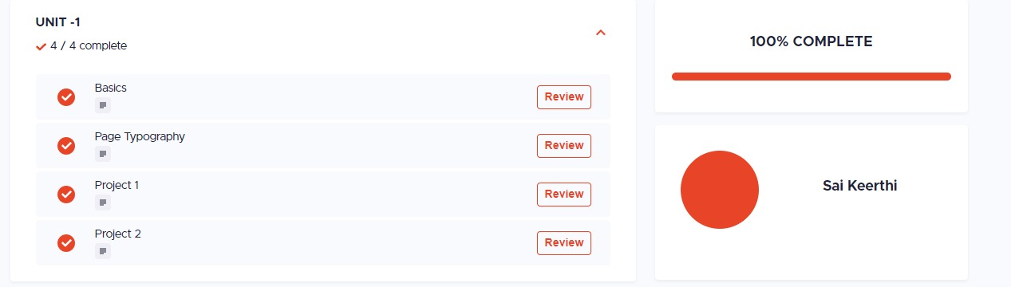

## advantages & disadvantages

1. canva is a user- friendly, drag- and- drop desing tool, making it accessible for users with little to no design experience

2.you can easily customize the templates b adding your

logo, changing colour, fonts, and adjusting the layout to match your brand identity

3. while canva is user friendly, it may not offer the same

level of customization and design control as professional

design software like abobe in design.

4.The free version of canva watermark on your

Designs, which may not give a fully professional I impression . to remove it , you need to upgrade to

The pro version.

# applications

integration with instagram stories and reels.

* Advanced analytics for post performance
* Expanding to other platforms

Supporting multiple languages

# conclusions

The intagram post application project successfully created a robust

Mobile app that simplifies the process of creating, eading, and sharing posts on instagram. The project overcame technical challenges, integrated with instgram APL, and provided valuable features like post scheduling, hashtag suggestion and analytics.